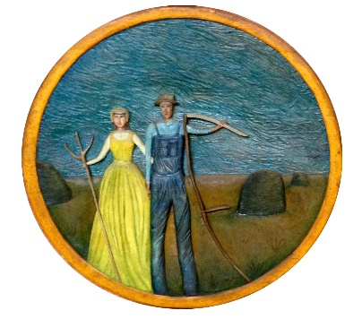
Michigan Farmers’ Hall of Fame Application for Induction
Qualifications: You must be 60 years of age or older and have actively farmed for at least 20 years.

Name___________________________________ Date of Birth __________________
Spouse _________________________________ Date of Birth __________________
Address _____________________________ City ______________ Zip ___________
County ______________ Township _______________ Phone __________________
Email address ______________________________Cell Phone__________________
Years of Active Farming ________ Acres owned __________ Rented ___________
Actively Farming or Retired _______ Type of Farming ________________________
Explain in detail your past and present farming activities: crop history, livestock
history, how you built your farm operation, modifications, innovations, etc. Do you
have any awards, honors, etc. Include articles and letters of support. *
______________________________________________________________________
______________________________________________________________________
______________________________________________________________________
Explain in detail your involvement in Community Services and Farm Organizations: Local, County, and State. *
______________________________________________________________________
______________________________________________________________________
______________________________________________________________________
- Use extra sheets if needed for the information you may have.

Date of Application _____________________ Signature of Applicant _____________________

Mail Application to: Harry Pratley
12070 Stone Jug Road
Battle Creek, MI 49015

